DAY 2-DOCKER

1. Create docker credentials:  
   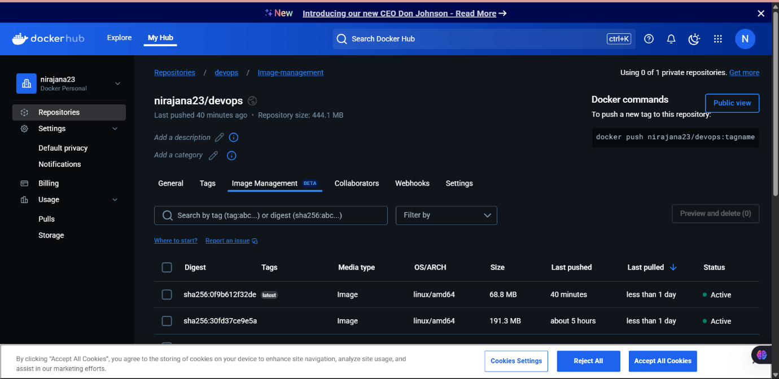

2) Pipeline script :  
pipeline {

agent any

tools {

jdk 'java20'

nodejs 'node20'

}

stages {

stage('Clean Workspace') {

steps {

script {

echo "Cleaning workspace..."

deleteDir() // Deletes everything in the Jenkins workspace before starting

}

}

}

stage('Git Checkout') {

steps {

script {

git branch: 'main',

credentialsId: 'github_seccred',

url: 'https://github.com/Nirajana-Selvaraj/day3devops.git'

}

}

}

stage('Install Node') {

steps {

script {

sh '''

if [ -f package.json ]; then

echo "package.json found. Running npm install..."

npm install

else

echo "ERROR: package.json is missing. Skipping npm install."

exit 1

fi

'''

}

}

}

stage('Docker Build & Push') {

steps {

script {

withDockerRegistry(credentialsId: 'docker', toolName: 'docker') {

def imageName = "nirajana23/devops"

def tag = "latest"

sh "docker build -t ${imageName} ."

sh "docker tag ${imageName} ${imageName}:${tag}"

sh "docker push ${imageName}:${tag}"

}

}

}

}

stage('Deploy Docker Container') {

steps {

script {

// Stop and remove the existing container if it's running

sh "docker stop devops_container || true"

sh "docker rm devops_container || true"

// Run the new container

sh "docker run -d --name devops_container -p 8080:80 nirajana23/devops"

}

}

}

}

}

3)Credentials - Docker  
4)Output  
